News app api :

We implemented news app API using java script.

We created our API key and we can give variety of request. firstly, we can make a request using API key for headlines of BBC news or any other news. we can also give custom request about the topic we want to search news about.

Login page:

This is the home page

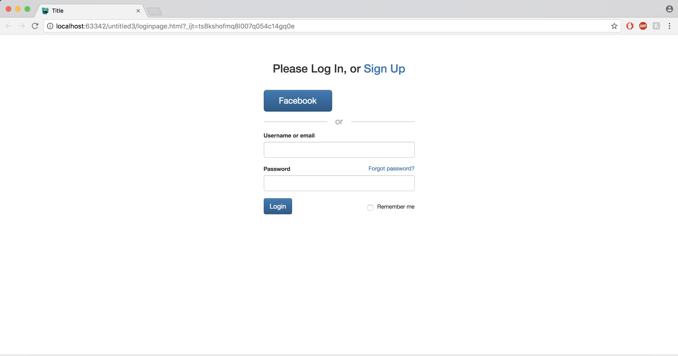

Registration page : we created registration page using bootstrap , this page consist of a form with inputs such as name email password . etc

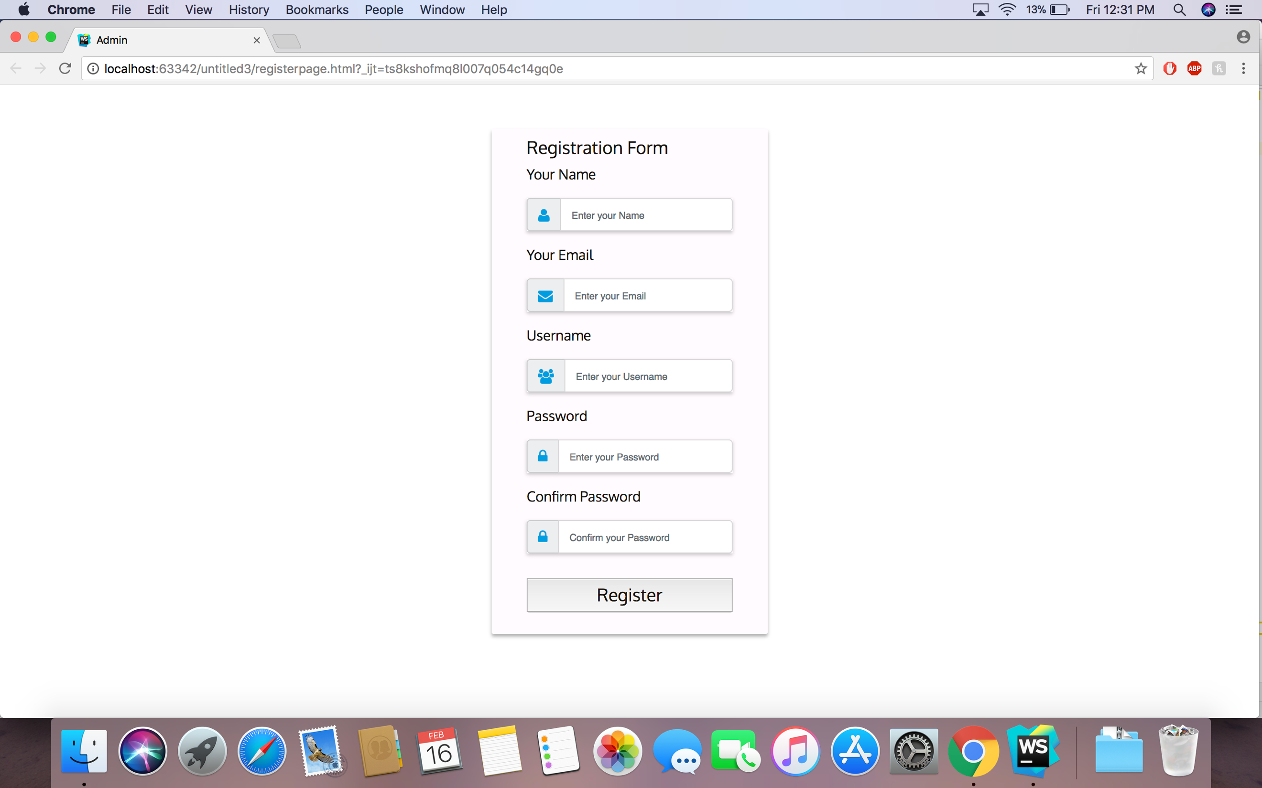

Home page

Home page we have to select any news source from the select dropdown .



After selecting any news source the home page displays head lines of that news . we can call this using news api .

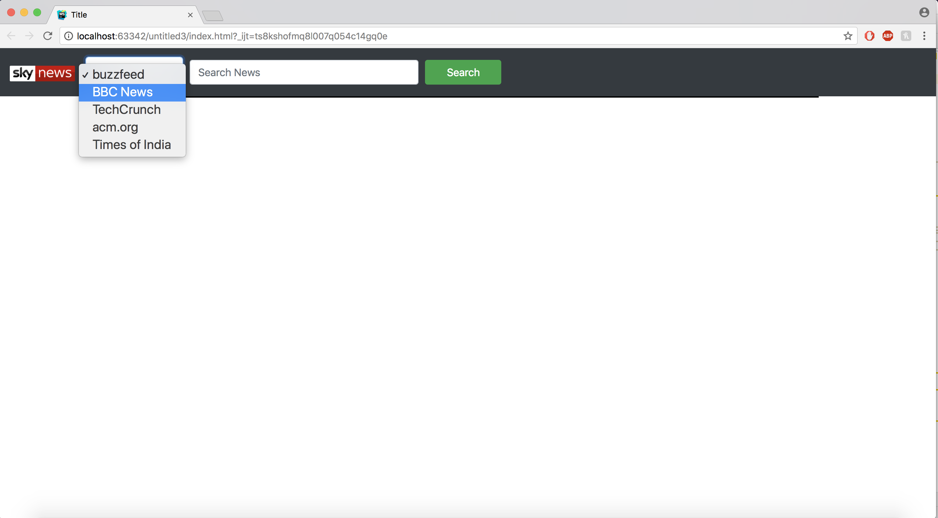

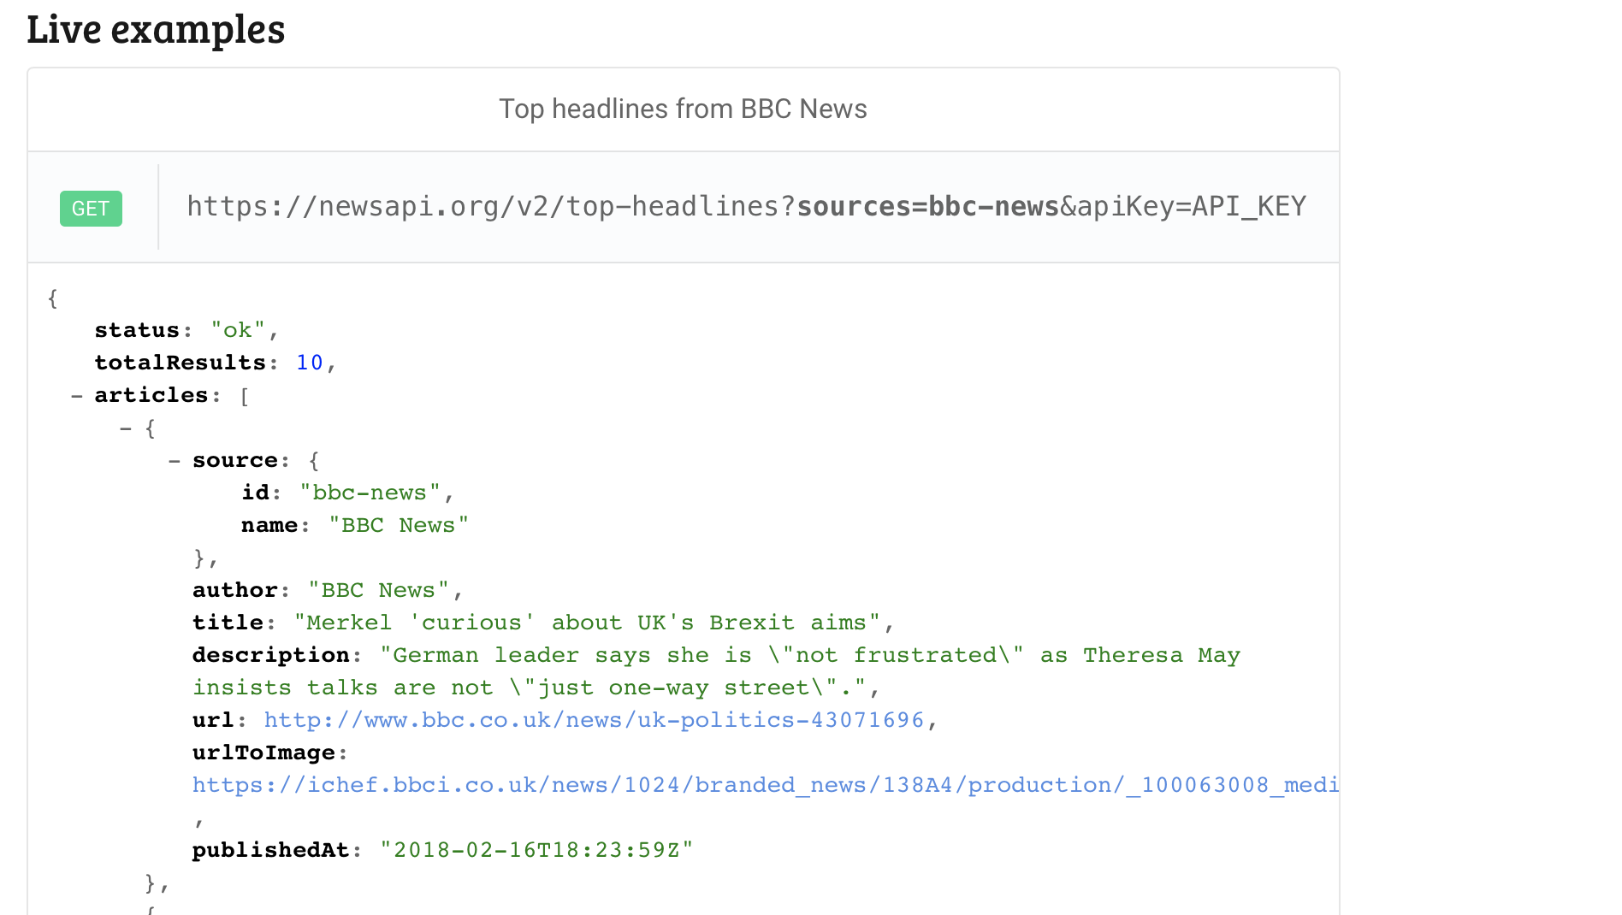

Head lines :

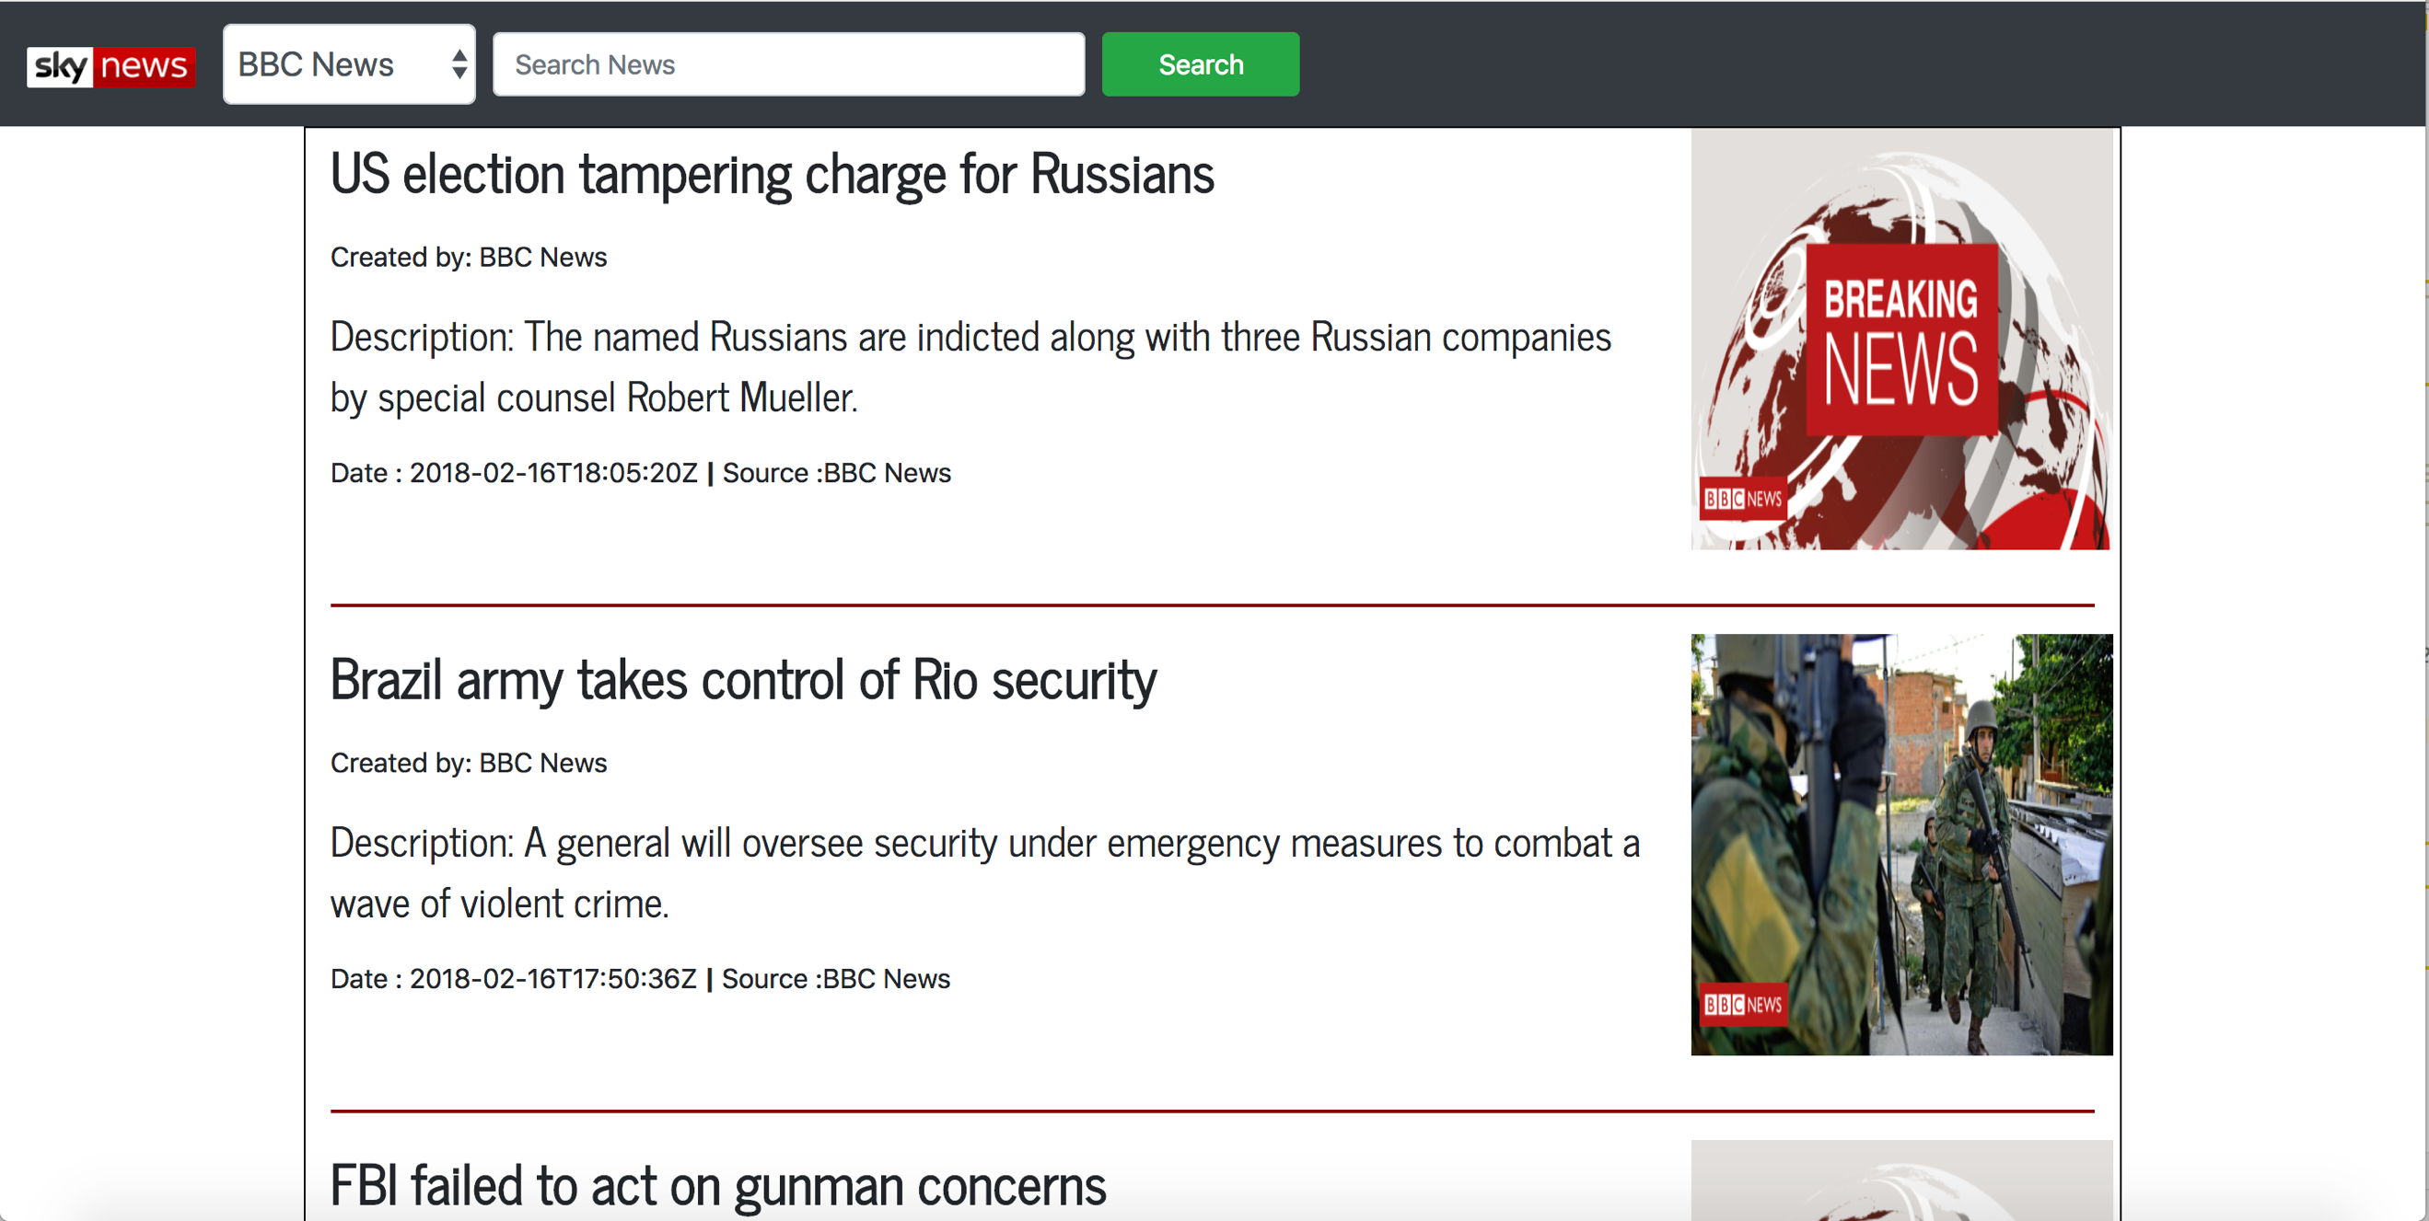



We can search. News about any particular topic from any source we can provide from select dropdown.

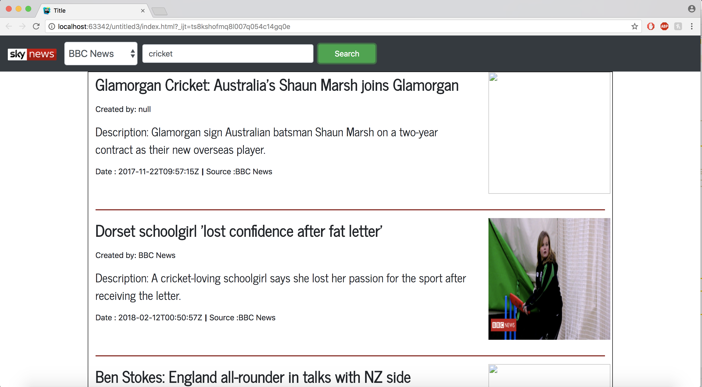

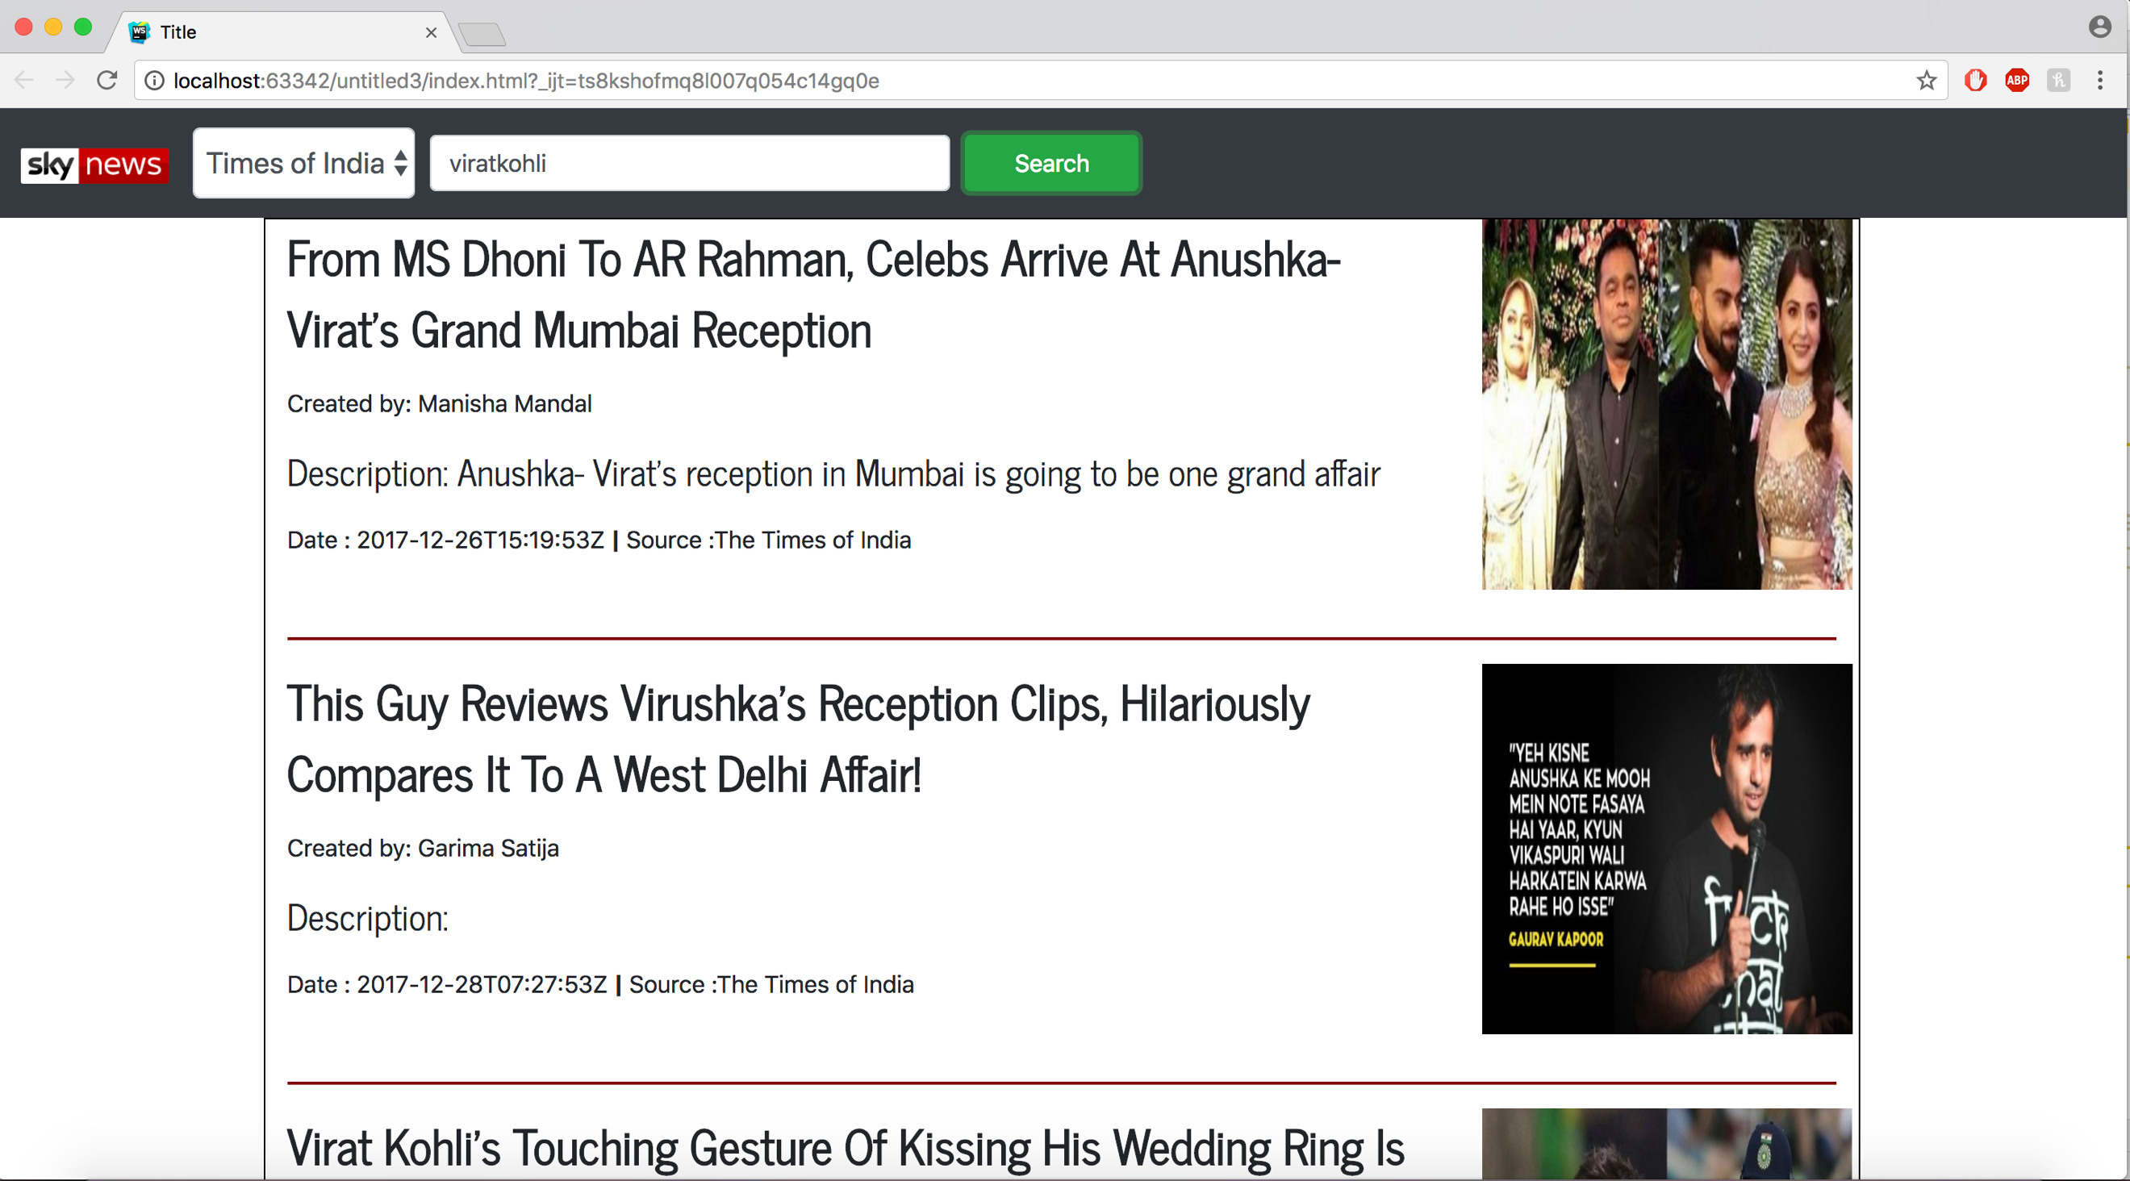

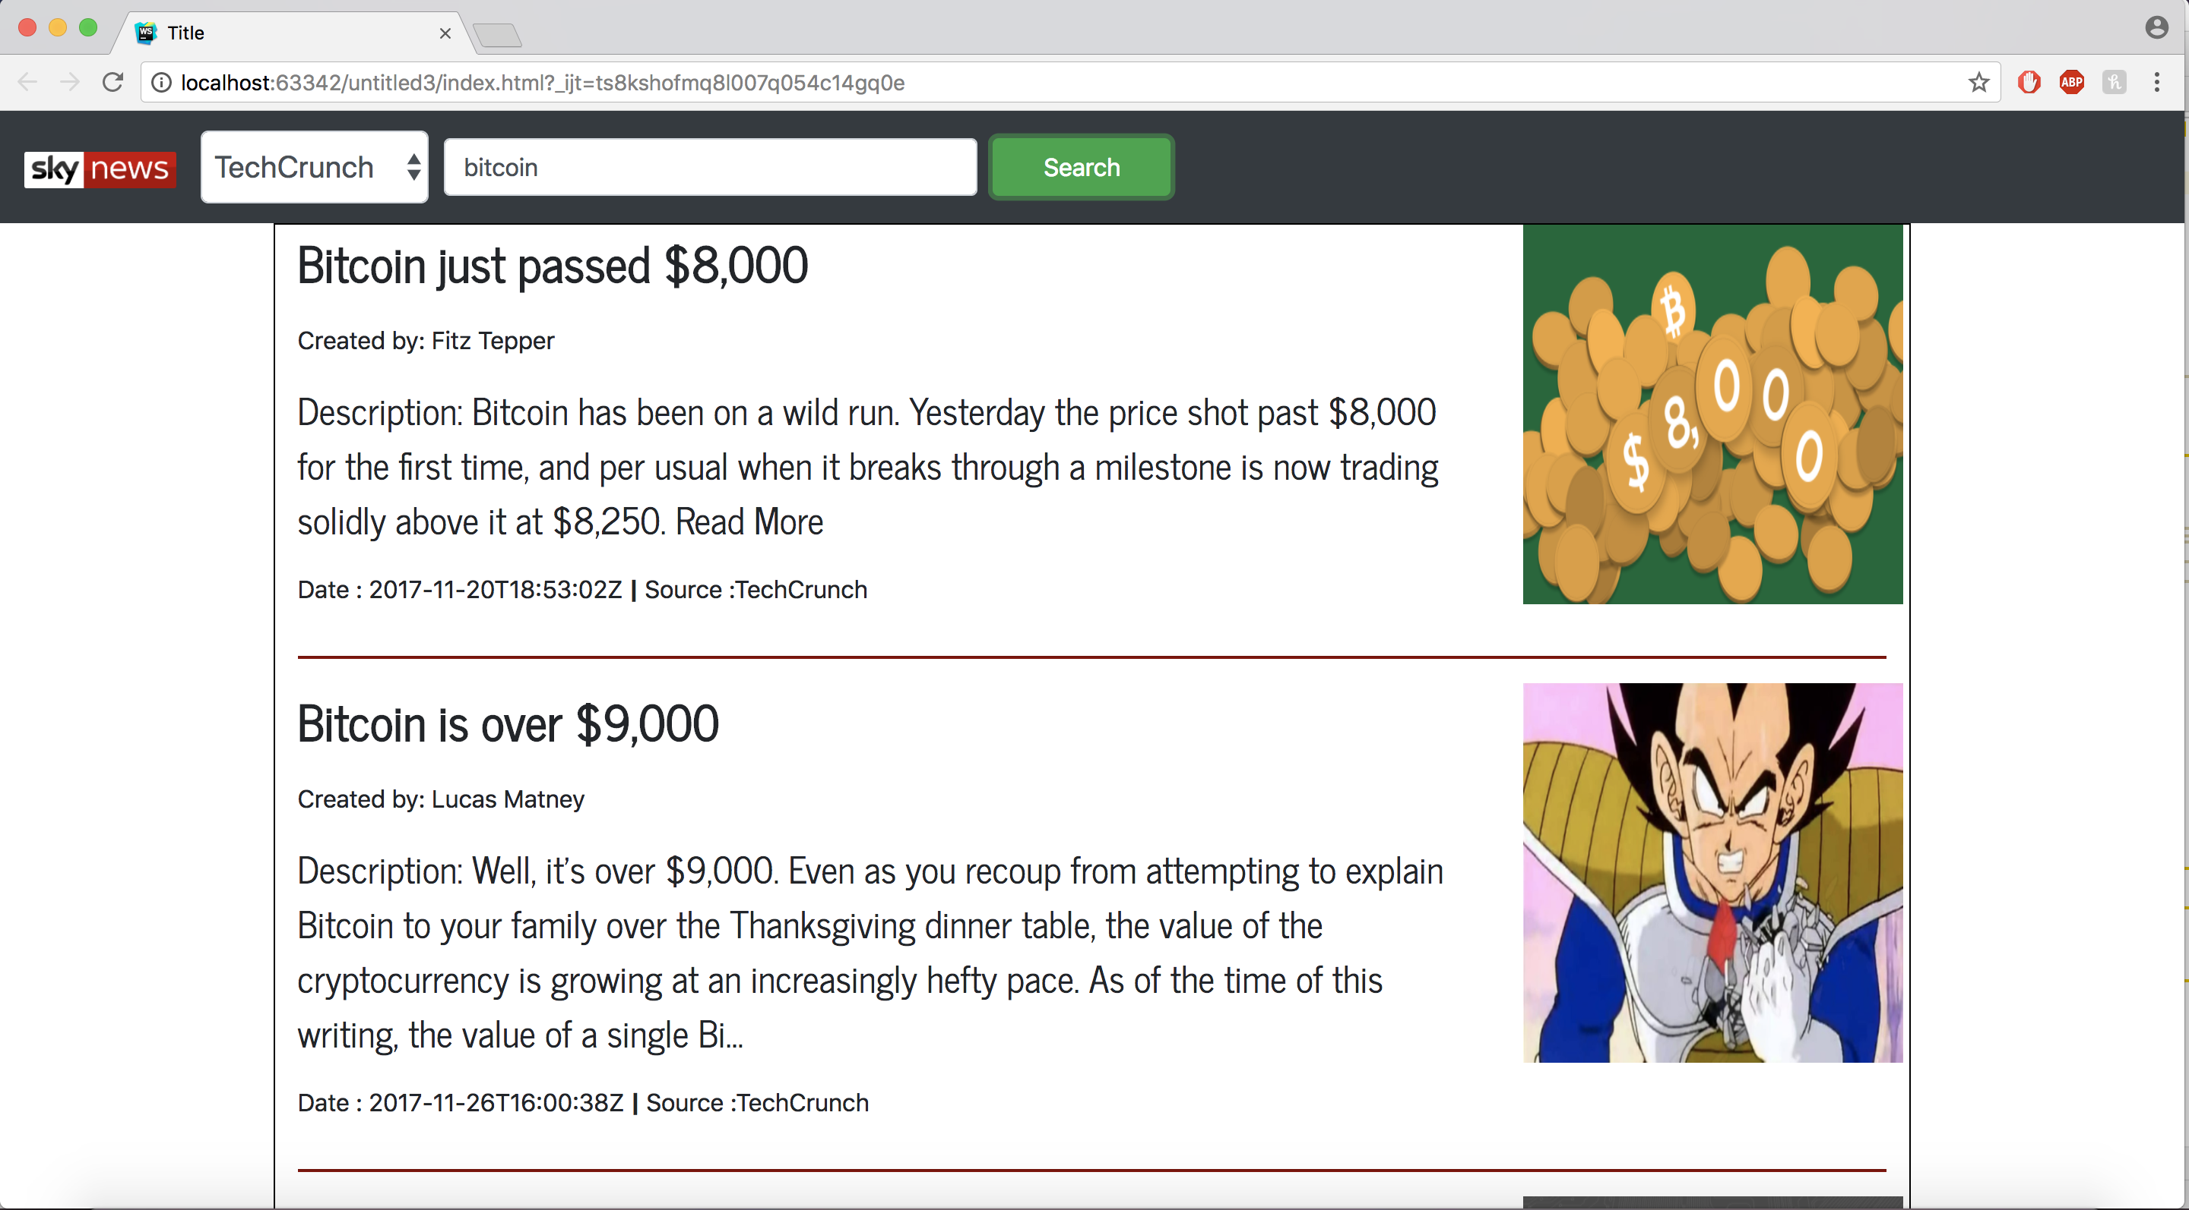

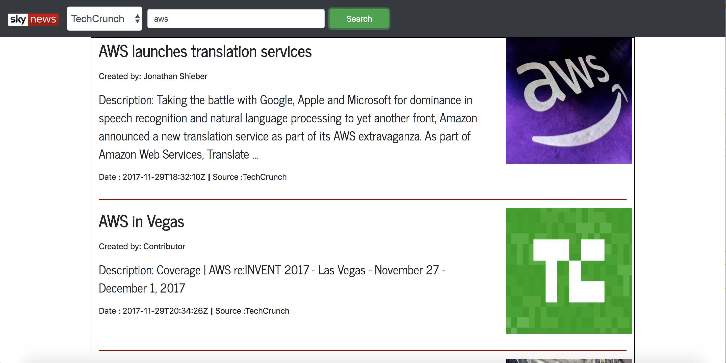

TIC TAC TOE:

We created tic tac toe game using angularJS,

